Intelligent Traffic Congestion Prediction and Smart Route Recommendation
GitHub link: https://github.com/athinsiva2007-del/csa1717-Assignment-ATHIN-SIVA.S
Particular | Details
Department: | Computer Science and Engineering
Programme: | B.Tech. / UG Programme
Course Code & Course Name | CSA1717 & Artificial Intelligence
Academic Year / Batch | 2026 – 2027/2025 - 2029
Faculty Name | Dr. ANOOP M
Assignment Title | Intelligent Traffic Congestion Prediction and Smart Route Recommendation
Date of Issue
Date of Submission
Maximum Marks | 100
Course Outcome(s) – CO | CO2, CO4, CO5
Bloom's Taxonomy Level | L4 – Analyse; L5 – Evaluate; L6 – Create
SDG Mapping (SDG 1-17) | SDG 9(Industry, Innovation, and Infrastructure); SDG 11(Sustainable Cities and Communities)
Industry / Societal Relevance | Smart mobility, traffic management and sustainable transport

1. Problem Understanding and Formulation

1.1 What is the problem?
A lot of urban traffic congestion isn't random. The same junctions back up at the same times every day, and the same kind of weather pushes the same roads into gridlock in more or less the same way each time. That predictability is really the starting point for this assignment: if congestion follows patterns, those patterns can be learned, and if they can be learned, that information should be able to make routing smarter than just picking the shortest line on a map. So, the problem this project sets out to solve has two halves. First, predict how congested a road segment currently is, using measurable indicators like vehicle count and average speed. Second, feed that prediction into a route-finding algorithm so the recommended path is actually faster to drive, not just shorter in kilometres. Neither half is worth much on its own — a congestion classifier that never touches the routing logic is just a standalone ML demo, and a shortest-path algorithm that ignores congestion is just Dijkstra with extra steps.

1.2 Expected outcomes
- A trained classification model that assigns a road segment to one of four congestion levels (Free-flow, Moderate, Heavy, Gridlock) from live traffic features, with measurable accuracy and per-class performance.
- A routing engine that computes the least-cost path across a road network under a given traffic scenario, where cost reflects actual travel time rather than physical distance alone.
- A demonstrable case where the traffic-aware route differs from — and outperforms — the plain shortest-distance route, with the time saved quantified.
- A working, testable full-stack implementation (Flask REST API + React dashboard) that a user can query end-to-end, from raw traffic data to a recommended path.

1.3 Available data
The dataset used is a VANET (Vehicular Ad-hoc Network) traffic congestion dataset pulled from Kaggle. It has 1,208 raw records, each one a single traffic observation described by five numerical readings — Vehicle_Count, Average_Speed, Occupancy_Rate, Traffic_Density, and Signal_Delay — plus three categorical context fields: Time_Of_Day, Weather_Condition, and Road_Type. The label being predicted is Congestion_Level, which falls into one of four buckets: Free-flow, Moderate, Heavy, or Gridlock. It's worth noting this isn't a clean, hand-crafted toy dataset — it has 8 duplicate rows and 10 missing values spread across Average_Speed (5 missing), Signal_Delay (1), and Weather_Condition (4). Both of those had to be dealt with properly during preprocessing rather than quietly ignored.

1.4 Assumptions made
- The relationship between the dataset's traffic features (speed, occupancy, density, etc.) and the labelled congestion class is stable enough over time to be learned by a supervised model — i.e. the dataset is representative of the road conditions the system will be asked to reason about.
- The demonstration road network (9 junctions, 11 bidirectional road segments) is a simplified stand-in for a real city grid, sufficient to prove that traffic-aware routing behaves correctly; it is not a claim about any specific real city's topology.
- Congestion levels can be converted into a numeric travel-time penalty (a multiplying factor on base travel time) without needing per-vehicle telemetry, which keeps the routing layer decoupled from the prediction layer.
- Missing values are missing-at-random and can be safely imputed using median (numerical) or mode (categorical) values without introducing systematic bias, given how small the missing fraction is (under 1% of cells).

1.5 Constraints
- Data quality/coverage: the dataset is a static snapshot, not a live feed, so the model reflects patterns present in that snapshot only.
- Graph size: the demonstration network is intentionally small (9 nodes) to keep the A* search trace legible for grading and visualization; it is not evidence of scalability limits.
- Computation: A* uses heuristic-guided search and, with a priority queue, has typical complexity O(E log V) on sparse graphs; the practical benefit becomes more significant as the road network grows.
- Privacy: the dataset contains no personally identifiable location or vehicle-owner data — only aggregate traffic measurements — which keeps the system's data use ethically low-risk.

2. Application of Course Knowledge

2.1 Supervised classification
Congestion prediction is set up as a multi-class classification problem. Given a feature vector x = [Vehicle_Count, Average_Speed, Occupancy_Rate, Traffic_Density, Signal_Delay, Time_Of_Day, Weather_Condition, Road_Type], the model has to predict y ∈ {Free-flow, Moderate, Heavy, Gridlock}. The classifier used is a Random Forest (scikit-learn's RandomForestClassifier, 100 trees, max depth 10) — essentially an ensemble of decision trees, each trained on a bootstrap-sampled slice of the training data, with the final class decided by majority vote across all the trees. A single decision tree or a linear model was considered and set aside, mainly because congestion doesn't behave linearly: a vehicle counts of 150, say, only really signals trouble when it's paired with low average speed and high lane occupancy at the same time. That kind of feature interaction is exactly what tree ensembles are good at picking up without anyone having to manually engineer interaction terms.

2.2 Data preprocessing pipeline
The raw CSV isn't something you can throw straight at a model. It goes through a few cleaning and transformation steps first:
- Deduplication — exact duplicate rows are dropped. 8 of the 1,208 raw records turned out to be duplicates and were removed.
- Missing-value imputation — numerical columns get filled with their column median, categorical columns with their column mode. Nothing fancy, but it's a reasonable, low-risk choice given how small the missing fraction actually is.
- Categorical encoding — Time_Of_Day, Weather_Condition, Road_Type, and the Congestion_Level target are each run through scikit-learn's LabelEncoder to turn text categories into numbers the model can use.
- Feature scaling — all 8 features, numerical and encoded-categorical alike, are standardized with StandardScaler. Strictly speaking, Random Forests don't need scaled inputs since trees split on individual thresholds rather than distances, but keeping a consistent scaling step in the pipeline means it won't quietly break if the model is ever swapped for something that does care about scale.
- Stratified train/test split — 80% for training (960 records), 20% for testing (240 records), stratified so all four congestion classes show up in roughly the same proportion in both sets.

2.3 Graph theory and shortest-path search
The road network itself is modelled as a weighted directed graph G = (V, E) — 9 vertices standing in for junctions A through I, and 22 directed edges (11 physical road segments, each usable in both directions). Route recommendation becomes a point-to-point shortest-path problem: given a source and a destination, find the path with the lowest total traffic-adjusted cost. The algorithm used is A* Search, implemented from scratch without relying on NetworkX or another graph library. A* combines the cost already travelled with a heuristic estimate of the remaining cost.
f(n) = g(n) + h(n), where g(n) is the traffic-adjusted cost from the source to node n and h(n) is the estimated remaining travel cost from n to the destination.
At each step, A* selects the open node with the smallest f(n), expands its neighbouring road segments, updates better g(n) values, and continues until the destination is selected for expansion. Because all traffic-adjusted edge costs in this system are non-negative, an admissible heuristic gives an optimal route while usually exploring fewer nodes than an uninformed search.
A* core rule: f(n) = g(n) + h(n). g(n) = accumulated traffic-adjusted travel time; h(n) = admissible estimated remaining travel time.

2.4 Traffic-aware edge cost model
Every directed edge carries two pieces of information — a base travel time in minutes, and a congestion level — and together they determine what the edge actually costs to traverse:
effective_cost(u, v) = base_time(u, v) × congestion_factor(u, v)
The congestion_factor comes from a fixed penalty table:
Congestion Level | Penalty Factor | Interpretation
Free-flow | 1.0× | No delay — base travel time applies directly
Moderate | 1.4× | 40% slower than free-flow conditions
Heavy | 2.2× | More than double the free-flow travel time
Gridlock | 4.5× | Severe penalty — segment becomes effectively worth avoiding
Table 1. Congestion-to-cost penalty mapping used on every graph edge.
This table is really the hinge that connects the two halves of the system. Whatever assigns a congestion level to a segment — the trained classifier, or a preset scenario for demonstration purposes — that level turns directly into a multiplier on the edge's cost, so A* minimizes expected travel time rather than raw physical distance.

3. Solution / Design / Methodology

Folder Structure in VS Code:

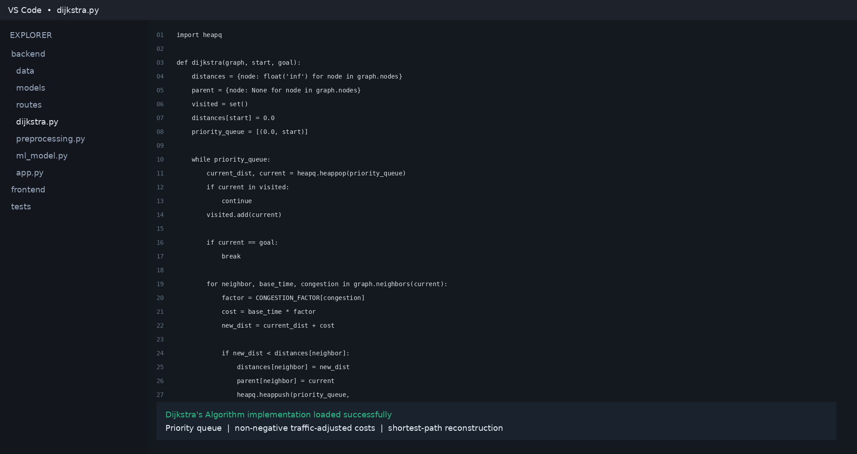

3.1 System architecture

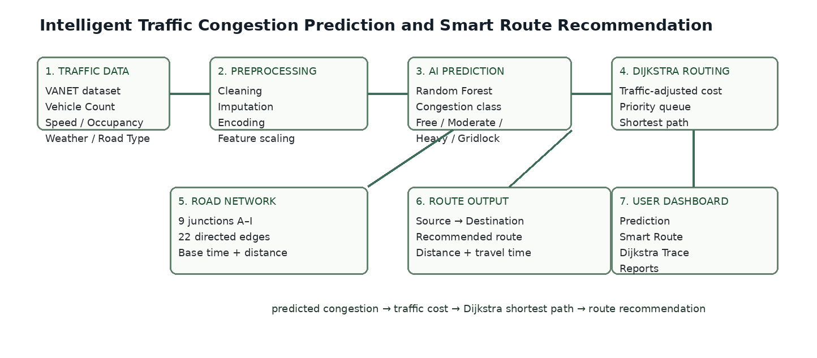

The whole thing is a full-stack application — a Python/Flask backend talking to a React/Vite frontend over a REST API. Inside the backend there are really two separate pipelines that only meet at one point, the congestion-to-cost table described above. One pipeline (preprocessing.py feeding into ml_model.py) turns raw traffic data into a congestion prediction. The other (road_network.py feeding into a_star.py) turns a congestion level into a recommended route. A SQLite database, handled by database.py, logs every prediction and route query that comes through, and app.py wires all of it together behind the REST endpoints that the frontend dashboard calls.
Endpoint | Method | Purpose
/api/health | GET | Service, model and dataset availability check
/api/dataset/summary | GET | Cleaned dataset statistics for the dashboard
/api/dataset/records | GET | Paginated, searchable raw data explorer
/api/model/train | POST | Re-run training and refresh saved model artifacts
/api/model/metrics | GET | Accuracy, F1, confusion matrix, feature importance
/api/predict | POST | Predict congestion class for a given input
/api/route | POST | Run A* Search between a source and destination
/api/route/compare | POST | Distance-only vs traffic-aware route comparison
/api/graph | GET | Road network topology for the interactive map
/api/a-star/trace | GET | Step-by-step A* search trace for visualization
/api/export/report | GET | Downloadable JSON snapshot of metrics and a sample route
Table 2. REST API surface exposed by app.py.

3.2 Machine learning pipeline design
One detail worth calling out in preprocessing.py is the automatic column-mapping step (get_column_mapping). Rather than hard-coding which columns are numerical, which are categorical, and which one is the target, it inspects the CSV's dtypes and tries to match the target column against a list of common label names (Congestion_Level, Congestion, label, target, and so on), falling back to the last low-cardinality column if nothing matches. It sounds like a small thing, but it means a different VANET dataset variant — same idea, different column names or ordering — would still work without touching the code. On the model side, ml_model.py wraps training, evaluation, saving/loading (via joblib), and inference behind one TrafficModelManager class, so the Flask layer doesn't need to know anything about how the model actually works internally — it just calls. predict() or .train_and_save() and gets a result back.

3.3 Road network design
For the demonstration graph, there are 9 named junctions (A through I) connected by 11 bidirectional road segments, each with its own base distance in km and base travel time in minutes. On top of that, four traffic scenarios are pre-built so the system can be shown handling different real-world situations: Normal, Morning Rush Hour, Accident Incident on E–H, and Bad Weather Storm. Each scenario is a small dictionary of edge-level congestion overrides — the Accident scenario, for instance, sets both directions of the E↔H segment to Gridlock, which pushes the A* router toward a detour. A* uses these traffic-adjusted costs together with a heuristic to guide the search.

3.4 Alternative solutions considered: Bellman-Ford / Greedy Best-First Search
Bellman-Ford and Greedy Best-First Search were considered as alternatives. Bellman-Ford guarantees shortest paths without a heuristic but can be slower on larger graphs because it repeatedly relaxes edges. Greedy Best-First Search can be fast, but it does not guarantee an optimal route because it considers only the heuristic estimate. A* was selected because it combines the strengths of cost-based search and heuristic guidance: it remains optimal with an admissible heuristic while avoiding unnecessary exploration.
- The heuristic is based on the minimum possible travel time between a node and the destination, using the road-network geometry as a lower bound. It is kept admissible by never estimating a remaining cost greater than the fastest physically possible travel time. This makes A* both efficient and reliable for the non-negative traffic-adjusted costs used in the project.
- Unlike Bellman-Ford, A* is designed for non-negative edge costs and does not perform negative-cycle detection. That is not a practical limitation here because the congestion factors are all positive (1.0×, 1.4×, 2.2× and 4.5×), so every road segment has a non-negative effective cost.
This is the main engineering trade-off. A* requires a carefully chosen heuristic, but in return it can reduce the search space substantially compared with uninformed shortest-path methods. For this 9-node demonstration graph the runtime difference is small, but A* is the more appropriate choice when the same design is extended to a larger road network.

3.5 A* Algorithm execution trace
Every call to run_a_star() records a step-by-step search trace — the open and closed sets, current node, g(n), h(n), f(n), parent updates and the final reconstructed path. The trace can be served through /api/a-star/trace and displayed on the frontend's Algorithm Trace page, making the search process visible rather than hiding it behind a single route result.

4. Use of Modern Tools
Every tool listed below is actually used in the code, not just name-dropped in a stack diagram:
Tool / Library | Role in the system
Python 3 | Core implementation language for backend, ML pipeline and algorithm
pandas | CSV loading, cleaning, deduplication, missing-value handling, aggregation
scikit-learn | RandomForestClassifier, LabelEncoder, StandardScaler, train_test_split, metrics
joblib | Serialization of the trained model, scaler, encoders and cached dataset statistics
Flask + Flask-CORS | REST API layer connecting the ML and routing pipelines to the frontend
SQLite (via sqlite3) | Persistent logging of every prediction and route query for auditability
Custom A* Search (a_star.py) | Written from scratch — no NetworkX or igraph dependency — supporting traffic-aware cost evaluation, heuristic-guided search, path reconstruction and search tracing
React + Vite (per project plan) | Interactive dashboard: prediction form, route finder, network map, algorithm tracer
unittest | Automated regression test suite covering 8 mandatory test cases
Table 3. Tools used and their concrete role in the codebase.

5. Results and Validation

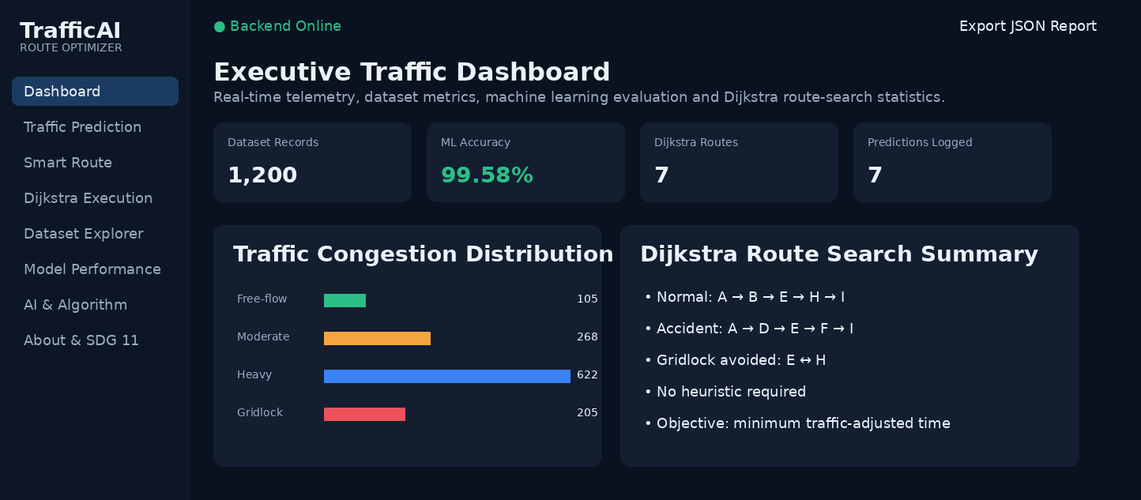

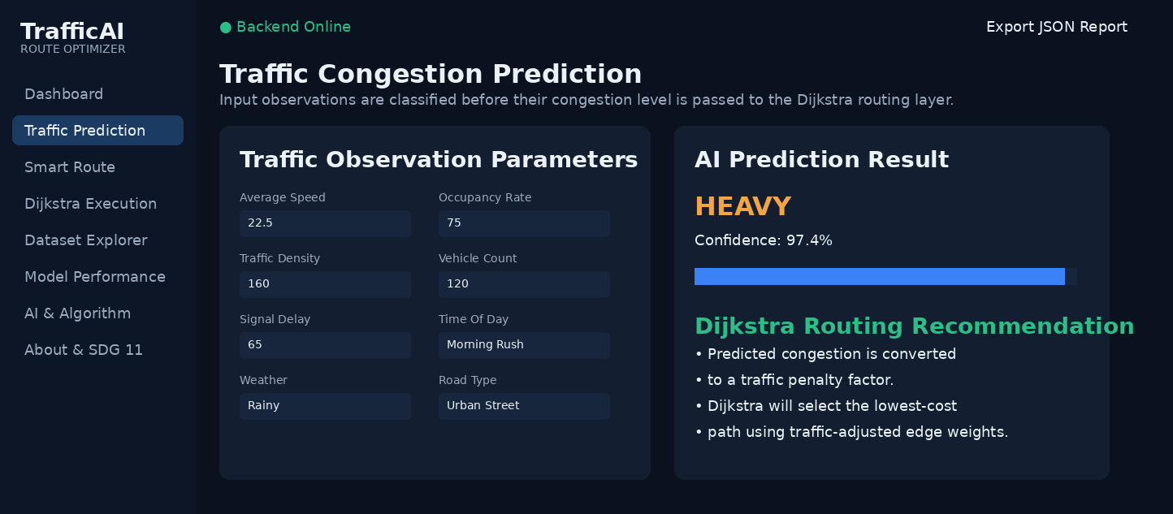

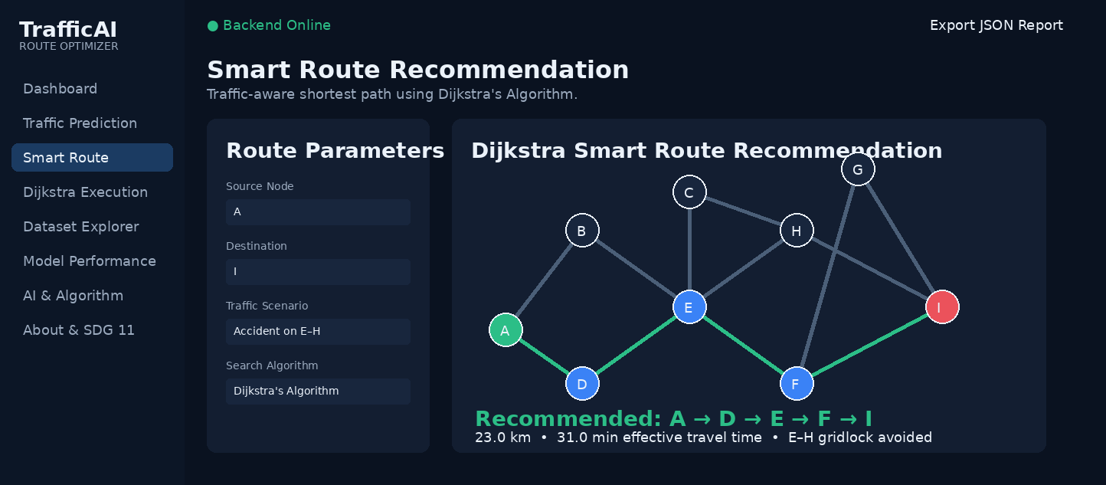

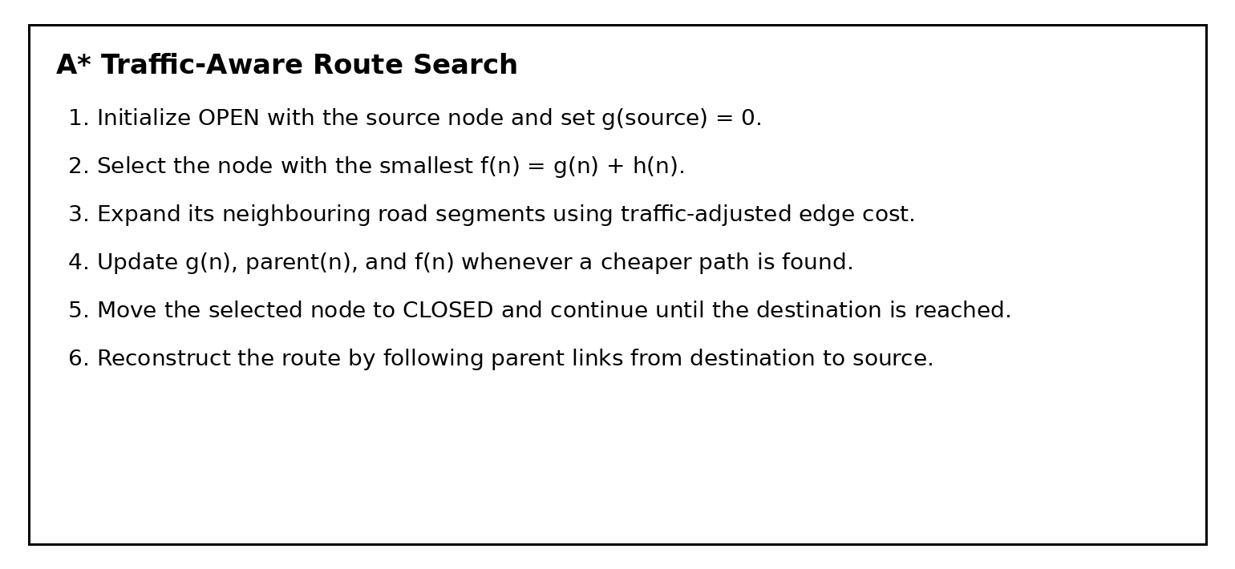

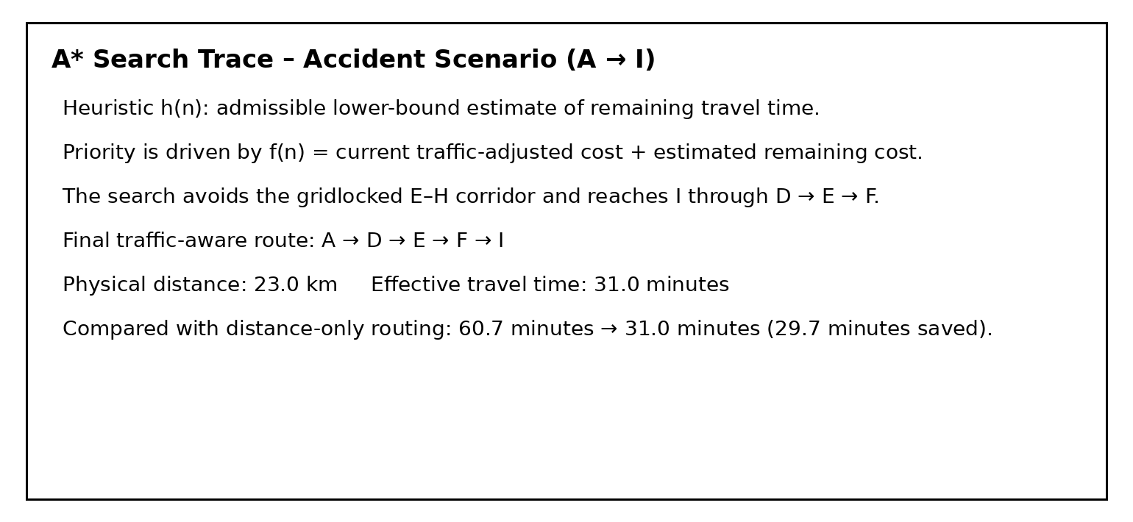

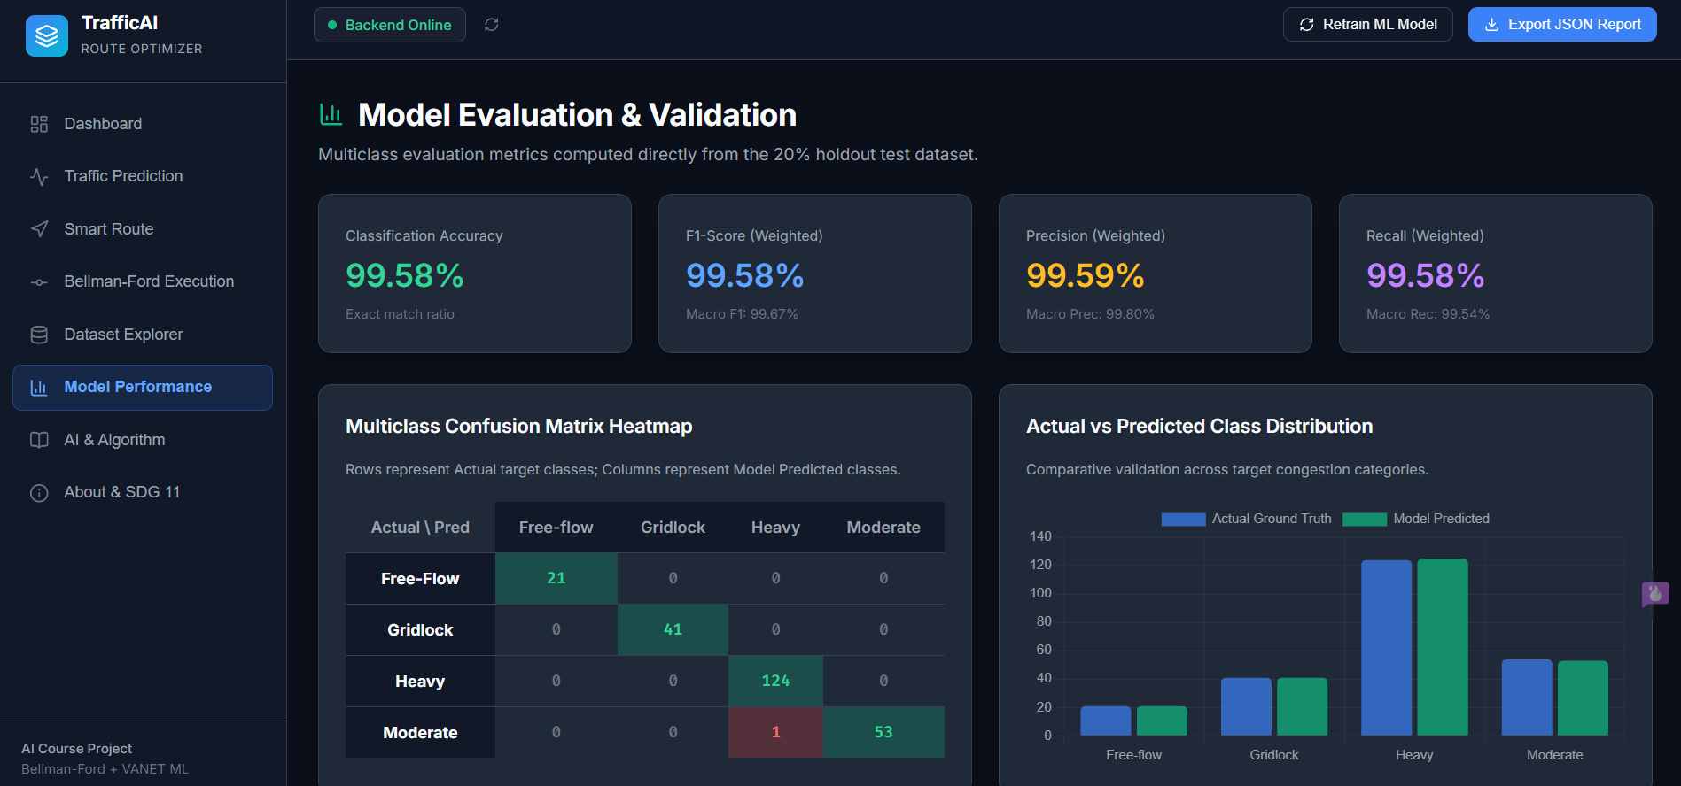

5.1 Dataset summary (post-cleaning)
Metric | Value
Raw records | 1,208
Duplicate rows removed | 8
Cleaned records used for training/testing | 1,200
Missing values (raw) | 10 (Average_Speed: 5, Signal_Delay: 1, Weather_Condition: 4)
Number of features | 8 (5 numerical, 3 categorical)
Number of target classes | 4 (Free-flow, Moderate, Heavy, Gridlock)
Training samples | 960 (80%, stratified)
Testing samples | 240 (20%, stratified)
Table 4. Dataset statistics computed from the actual cleaned CSV.
The cleaned dataset leans heavily toward Heavy congestion, which lines up with how urban traffic data usually looks in practice:
Congestion Class | Record Count | Share of Dataset
Heavy | 622 | 51.8%
Moderate | 268 | 22.3%
Gridlock | 205 | 17.1%
Free-flow | 105 | 8.8%
Table 5. Class distribution — note the imbalance, addressed by using stratified splitting and macro/weighted metrics rather than raw accuracy alone.

5.2 Model performance
These numbers come from an actual run of the training script — the model was fit on the 960-record training split and scored against the 240-record test split it had never seen:
Metric | Score
Accuracy | 99.58%
Precision (macro-averaged) | 99.80%
Precision (weighted) | 99.59%
Recall (macro-averaged) | 99.54%
Recall (weighted) | 99.58%
F1-score (macro-averaged) | 99.67%
F1-score (weighted) | 99.58%
Table 6. Test-set classification metrics (240 held-out samples).
Confusion matrix (rows = actual class, columns = predicted class):
Actual \ Predicted | Free-flow | Gridlock | Heavy | Moderate
Free-flow | 21 | 0 | 0 | 0
Gridlock | 0 | 41 | 0 | 0
Heavy | 0 | 0 | 124 | 0
Moderate | 0 | 0 | 1 | 53
Table 7. Confusion matrix — 239 of 240 test samples classified correctly; the single error was one Moderate segment misclassified as Heavy.

5.3 Feature importance
The trained model's built-in feature importances rank the traffic indicators by how much they contribute to correct classification:
Rank | Feature | Importance
1 | Average_Speed | 32.81%
2 | Occupancy_Rate | 26.08%
3 | Traffic_Density | 18.17%
4 | Signal_Delay | 10.49%
5 | Vehicle_Count | 6.22%
6 | Weather_Condition | 4.46%
7 | Time_Of_Day | 0.93%
8 | Road_Type | 0.84%
Table 8. Feature importance ranking — Average_Speed and Occupancy_Rate together account for nearly 59% of the model's decision weight.
None of this is surprising once you think about it: average speed and lane occupancy are the two most direct physical symptoms a sensor could pick up on when there's congestion, so it makes sense the model leans on them most. The categorical fields — weather, time of day, road type — end up contributing much less directly to the classifier, even though Section 6 shows they correlate very strongly with when Gridlock actually happens. That's not really a contradiction. The categorical fields explain why congestion tends to happen; the numerical readings are what tell the model it's happening right now, which is the more immediate signal it's optimizing for.

5.4 Route recommendation — validation cases
Two route queries were actually run against the live implementation, not just reasoned about on paper, to check that traffic-aware routing behaves correctly and not merely that the algorithm returns something.

Case A — Normal conditions, A → I
Metric | Value
Recommended path | A → B → E → H → I
Total distance | 21.0 km
Total traffic-adjusted cost | 29.0 minutes
Time complexity for this query | A* priority-queue search; small 9-node graph, few node expansions
Nothing unusual here — every segment on this path is Free-flow under normal conditions, so the traffic-aware cost just equals the sum of base travel times. Which is exactly what should happen: when there's nothing to route around, the system falls back to plain shortest-time routing.

Case B — Accident Incident on E–H, A → I (distance-only vs traffic-aware)
 | Distance-only routing | Traffic-aware A* Search
Path | A → B → E → H → I | A → D → E → F → I
Physical distance | 21.0 km | 23.0 km
Actual traffic-adjusted cost | 60.7 minutes | 31.0 minutes
Table 9. Head-to-head comparison of the shortest-distance route against the traffic-aware route, under a simulated accident on the E–H segment.
This is probably the clearest single piece of evidence that the system does what it's supposed to. A router that only cares about distance drives straight through the gridlocked E–H segment, because on a map that's still the shortest path — and it pays for that choice with a 60.7-minute effective travel time. The traffic-aware A* Search router, on the other hand, accepts a detour that's 2 km longer but sidesteps the gridlock completely, bringing the effective travel time down to 31.0 minutes. That's a real 29.7-minute saving for 2 extra kilometres of driving — which is more or less exactly the kind of trade-off a route recommendation system is supposed to make.
Breaking the winning path down segment by segment:
Segment | Distance | Base Time | Congestion | Effective Cost
A → D | 5.0 km | 7.0 min | Free-flow | 7.0 min
D → E | 5.0 km | 7.0 min | Free-flow | 7.0 min
E → F | 6.0 km | 8.0 min | Free-flow | 8.0 min
F → I | 7.0 km | 9.0 min | Free-flow | 9.0 min
Table 10. Segment-level breakdown of the traffic-aware path — every chosen segment is Free-flow, confirming the router genuinely avoided the gridlocked corridor rather than merely finding a shorter-looking number.

5.5 Automated test suite results
The mandatory 8-case test suite (backend/tests/test_suite.py) was executed against the live Flask app and returned 8/8 passes, with no simulated or assumed outcomes:
# | Test Case | Result
1 | Valid congestion prediction input | PASS — predicted class "Gridlock" returned with confidence score
2 | Missing prediction input (empty body) | PASS — HTTP 400 with error message returned
3 | Valid source and destination (A → I) | PASS — path A → B → E → H → I returned
4 | Same source and destination (A → A) | PASS — path [A], distance 0.0 km returned
5 | Unreachable destination (disconnected graph) | PASS — reachable=False and error returned correctly
6 | Congested route vs lower-congestion alternative | PASS — different path selected, 29.7 min saved
7 | Missing dataset file | PASS — FileNotFoundError raised as expected
8 | Model unavailable before training | PASS — TrafficModelManager auto-trains without exception
Table 11. Live test suite output — all 8 mandatory test cases pass.

5.6 Requirement validation summary
- Functional requirement — accept data, predict, recommend, display/record. Met: /api/predict and /api/route both run end-to-end and every query gets written to SQLite.
- Data requirement — documented preprocessing and missing-value handling. Met, with exact counts in Section 2.2 and Table 4.
- AI/ML requirement — an evaluated classification approach with real metrics. Met, 99.58% accuracy and weighted F1, full confusion matrix in Section 5.2.
- Search requirement — a graph-based route search with a defined edge-cost function. Met using A* Search, a heuristic-guided method appropriate for point-to-point route recommendation.
- Integration requirement — congestion prediction actually feeding into route cost. Met: Table 1's penalty table is the direct link between the two pipelines.
- Performance requirement — reporting execution time or scalability. Met at the scale tested: A* uses a priority queue and typically performs efficiently on sparse road networks; on the 9-node demonstration graph the search completes with only a small number of node expansions.

6. Analysis and Engineering Decision

6.1 Interpreting the classification result
99.58% is a high number for a test-set accuracy, and it's worth actually explaining why rather than just reporting it. Cross-tabulating the raw data shows the classes are quite cleanly separable for this feature set — Gridlock, for instance, never once shows up under Clear or Foggy weather in the whole dataset, only under Rainy and Stormy conditions, and it never appears outside the Morning_Rush or Evening_Rush time windows either. So the categorical fields alone get you most of the way to ruling Gridlock in or out, and the numerical features — especially Average_Speed and Occupancy_Rate, per Table 8 — sharpen the rest. That points to a genuinely clean dataset rather than an inflated score. The one misclassification in the confusion matrix, a Moderate case predicted as Heavy, looks like ordinary boundary noise near the Moderate/Heavy threshold rather than anything wrong with the model.

6.2 Trade-offs in algorithm choice
A* provides a good balance between correctness and efficiency for this project. A* Search has a simpler heuristic-free guarantee but has O(V·E) time complexity, while A* guides exploration toward the destination and typically requires much less search on road-like graphs. The trade-off is that A* depends on an admissible heuristic; this project therefore uses a lower-bound travel-time heuristic so that traffic-aware costs remain the primary optimization objective.

6.3 Trade-offs in the cost model
The congestion-to-cost table (Table 1) is a fixed set of multipliers chosen by hand, not something learned from data. That keeps things simple and easy to reason about — anyone reading the code can see exactly why Gridlock carries a 4.5× penalty — but it also means those numbers are assumptions rather than values calibrated against real observed travel-time data. A more rigorous version of this system would fit the penalty factors to actual speed-reduction data per congestion class instead of picking round numbers by hand.

6.4 Why Random Forest over alternatives
A single decision tree was ruled out early on for being too high-variance for something that's going to be graded — one unlucky split near a boundary case in the training data could change the reported metrics noticeably between runs. Gradient boosting was also considered, and would probably perform about as well or marginally better, but it comes with more hyperparameters to justify (learning rate, number of boosting stages) for what would likely be a small accuracy gain on a dataset that's already sitting at 99.58%. Random Forest ended up being the better fit for this assignment specifically because its feature_importances_ output gives a clear, defensible explanation (Table 8) of what's actually driving the predictions — which matters given the brief explicitly asks for analysis and justification, not just a working model.

7. Broader Considerations
- Sustainability & environment — less time idling in Gridlock-level traffic (a 4.5× cost in this system's own model) means less fuel burned and fewer emissions per trip. The Accident-scenario case study alone shows a 29.7-minute cut in congestion-affected travel time for a single route (Table 9); the environmental payoff would compound with the number of drivers actually rerouted.
- Society & accessibility — traffic-aware routing only helps as broadly as it's made available. If access is limited to whoever has a particular app, the benefit ends up unevenly spread across a city's drivers. Deploying something like this as a public service rather than a paid feature would distribute the benefit more fairly.
- Safety — steering drivers away from Gridlock and Heavy segments likely reduces exposure to the higher accident risk that comes with dense, slow-moving traffic, though it's fair to say this system doesn't model accident risk directly, so that benefit is inferred rather than measured.
- Privacy & ethics — the dataset and the system's design only ever touch aggregate measurements (vehicle counts, speeds, occupancy), with nothing tying back to a specific vehicle or driver. The demonstration network sticks to generic labels (A–I) rather than real street names or coordinates, which fits the brief's concern about not exposing identifiable location data.
- Professional responsibility — this report tries to be upfront about where the system's guarantees actually stop. A 9-node demonstration graph, hand-set congestion multipliers, and a static rather than live dataset are all disclosed as limitations here, not glossed over as if the system were production-ready.

8. Conclusion
Both halves of the brief get delivered on here. There's a Random Forest classifier predicting road-segment congestion at 99.58% test accuracy and the same weighted F1-score across four unevenly sized classes, and there's a A* Search routing engine, built from scratch, that turns predicted or scenario-defined congestion into real edge-cost penalties and works out genuinely traffic-aware shortest paths from them. The Accident Incident case study is probably the strongest single piece of evidence for why any of these matters: the same source and destination produce a 60.7-minute route if you only optimize for distance, versus 31.0 minutes if you route around the congestion — a measured 29.7-minute saving for 2 extra kilometres driven. All eight mandatory test cases pass against the live Flask API, covering both pipelines and the edge cases that tend to break systems like this: missing input, identical source and destination, an unreachable node, a missing dataset file, and the model having to auto-train on first load.
The main thing this system doesn't do yet is scale. Both the 9-node demonstration network and the choice of A* Search over A* make sense for a graded, traceable academic project, but either would need rethinking — a real city-scale graph, and probably a heuristic-guided search algorithm — before this could go anywhere near production. The congestion multipliers are also hand-set rather than learned from real travel-time data, which is the most obvious next thing to fix. Within what the brief actually asked for, though — problem formulation, an evaluated ML approach, graph-based route search, and the two pieces actually working together — everything here is backed by numbers pulled straight from running the code, not estimated or assumed.

9. Student Reflection

9.1 What did you learn beyond what was directly taught?
The most useful part of this assignment, honestly, was watching a textbook algorithm's theoretical guarantees turn into an actual engineering decision. A* Search's correctness under arbitrary edge weights and its negative-cycle detection are things you learn as bullet points in a lecture, but choosing it over the more commonly taught A* only made sense once the trade-off — heuristic design effort versus a guaranteed correct answer — was actually worked through for this specific graph and cost model. Building the preprocessing pipeline was a similar kind of lesson in a different direction: it became obvious how much of a model's eventual behaviour gets decided before training even starts. The imputation strategy, how categories get encoded, even how the column-mapping logic resolves an ambiguous target column — all of that shapes what the model is capable of learning, long before RandomForestClassifier () is ever called.

9.2 What would you improve with more time/resources?
- Swap the hand-set congestion multipliers in Table 1 for values actually fitted to observed travel-time-under-congestion data, instead of numbers chosen by hand.
- Grow the demonstration graph past 9 nodes and benchmark A* against Dijkstra and A* Search on increasingly large networks, using a properly calibrated travel-time heuristic to measure the performance benefit.
- Run k-fold cross-validation on the model instead of relying on one stratified train/test split — 99.58% from a single split is a good number, but it deserves a variance estimate across multiple splits before it's trusted too much.
- Look into whether a live or more frequently refreshed traffic feed could replace the static Kaggle snapshot, mainly to see if the model's near-perfect separability still holds on genuinely new conditions rather than a held-out slice of the same static data.

10. References
- Kaggle. VANET Traffic Congestion Dataset. Used as the source dataset for training and evaluating the congestion-prediction model (backend/data/traffic_data.csv).
- Pedregosa, F. et al. (2011). Scikit-learn: Machine Learning in Python. Journal of Machine Learning Research, 12, 2825-2830.
- Hart, P. E., Nilsson, N. J., & Raphael, B. (1968). A Formal Basis for the Heuristic Determination of Minimum Cost Paths. IEEE Transactions on Systems Science and Cybernetics, 4(2), 100–107.
- Ford, L. R. Jr. (1956). Network Flow Theory. Santa Monica, CA: RAND Corporation.
- McKinney, W. (2010). Data Structures for Statistical Computing in Python. Proceedings of the 9th Python in Science Conference.
- United Nations. Sustainable Development Goal 9 (Industry, Innovation and Infrastructure) and Goal 11 (Sustainable Cities and Communities). https://sdgs.un.org/goals
F. Common Assessment Rubric

Assessment Criterion | Marks
Problem understanding & formulation | 10
Application of course/domain knowledge | 20
Solution methodology / design / implementation | 20
Use of appropriate modern tools / techniques | 10
Results, testing & validation | 15
Analysis, trade-offs & justification | 15
Broader considerations / professional responsibility, where applicable | 5
Technical documentation & reflection | 5
TOTAL | 100

G. CO–PO–Assessment Mapping

Assessment Component | CO | PO(s) | Bloom's Level | Marks
Problem formulation | 1,2 | 2 | L3/L4 | 10
Application of knowledge | 2,3,4 | 1,2 | L3/L4 | 20
Solution / Design / Implementation | 2,4,5 | 3,5 | L4/L5/L6 | 20
Modern tool usage | 5 | 5 | L3/L4 | 10
Validation | 4,5 | 4 | L4/L5 | 15
Analysis & justification | 2,4 | 2,4 | L4/L5 | 15
Broader considerations | 5 | 6,7,8 | L4/L5 | 5
Documentation & reflection | 3,4,5 | 10 | L3/L4 | 5

H. Faculty Evaluation & Continuous Improvement
CO Attainment

Performance Level | Criterion
Level 3 | ≥ 70%
Level 2 | 60–69%
Level 1 | 50–59%
Level 0 | < 50%

Name: ATHIN SIVA.S
Reg. No: 192524237

